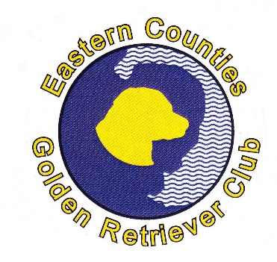 | SCAMP AND SASHA TROPHY

The Scamp and Sasha Trophy is awarded annually by the Club to the dog (owned by a member) which has accrued the highest number of points for places at Open and Championship shows (places in breed classes only - not variety classes).

Points are awarded as follows:
 | 1st | 2nd | 3rd | Res | VHC
Open Show | 3 | 2 | 1 | - | -
Championship Show | 5 | 4 | 3 | 2 | 1

No points are given for BOBs/Group Placings etc.
Members wishing to claim must submit details of awards achieved between January and December. You must give the date of the show, the name of the class and the placing.
All claims must be received by 31st January and the award will be announced at the Club’s AGM.
Claims should be sent to Sue Hush, tel 01945 587242, or via e-mail: hush_family@yahoo.co.uk

