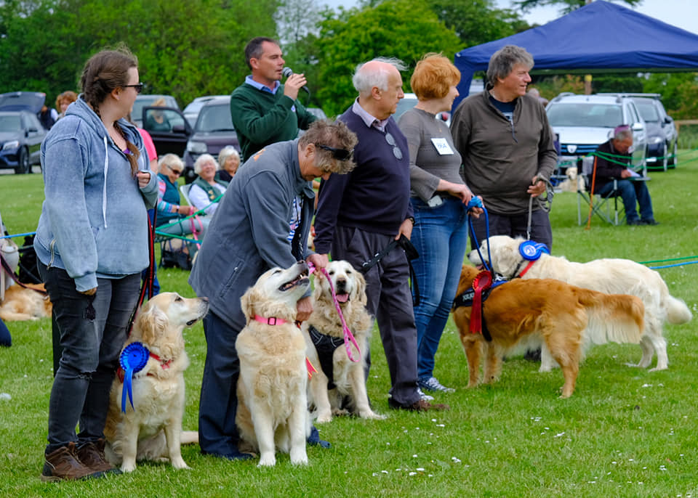  Eastern Counties Golden Retriever Club  Rescue Rally, Funday and Breed Club Open Show 2020  at Pear Tree farm, Hartest Suffolk, IP29 466  Sunday 24th May 2020  ECGRC would like to invite you and your dogs to join us for our annual fun day and fundraising event in the beautiful Suffolk countryside.  Further Rally Information from:  Nadine Barber - 01493 754946/nadinebarber@btinternet.com  Marc Wheeldon- marcwheeldon@gmail.com  Plus, our website at www.ecgrc.co.uk and Facebook page  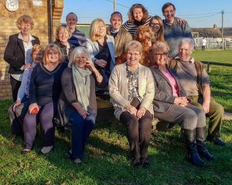  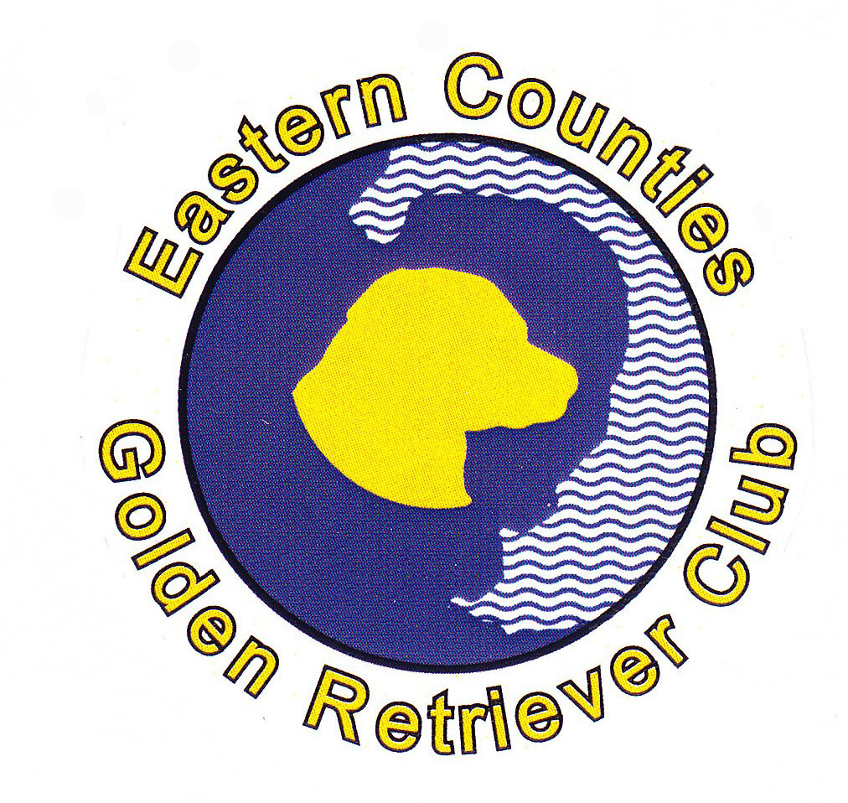 | The day will include:  Obedience Classes  Gundog Training Class  Novelty Classes  Land Scurry  Grooming and Trimming  Raffle  Teddy Tombola  KC Good Citizens Bronze Award  ECGRC Famous Homemade Cakes, refreshments and BBQ  And the main event of the day:  Rescue Parade: approx. 2pm, please register on arrival.  All participants in the parade will receive a rosette and the  ‘Cassie Memorial Trophy’ will be awarded.  ECGRC Open Show  judge- Lynn Bufton  please conatct:  Dianne Rourke-Knights  01728 635758  www.fossedata.co.uk  www.ecgrc.co.uk

