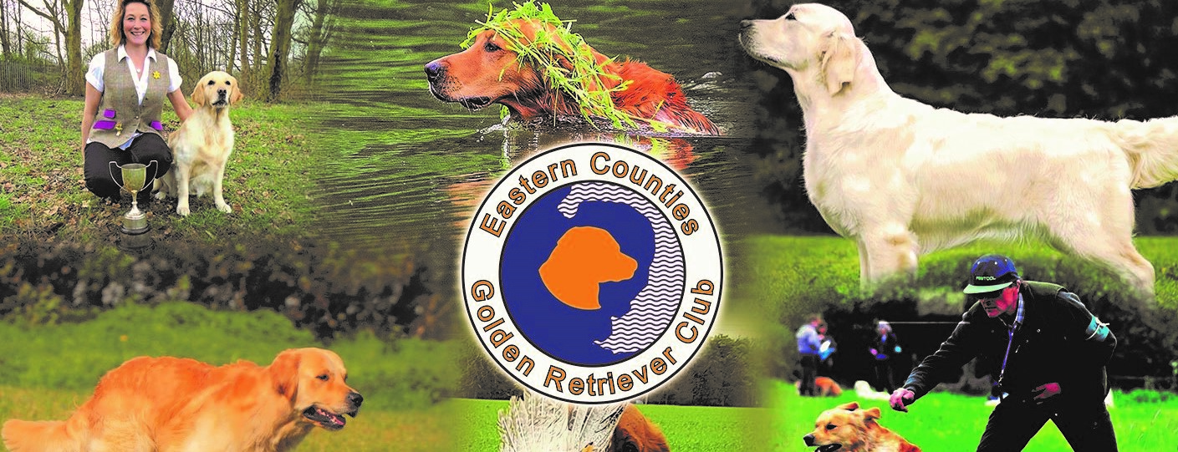
FUN DOG SHOW
Saturday 20th Sept 2025
Kirtling Village Hall, Kirtling, Nr Newmarket, CB8 9PB

Entry Fee: £2 per class * Rosettes 1st – 5th place * Goody bag for all class winners
Open to all Pedigree and Crossbreeds * Show Opens/Registration from 12 midday

Pedigree Ring (Judge David Knights) – Judging 11am
- AV Puppy (6-12 months)
- AV Junior (12-18 months)
- AV Hound/Terrier
- AV Gundog
- AV Working/Pastoral
- AV Toy/Utility
- AV Open ALL 1st Prize winners from classes 1-8 compete for
- AV Veteran 7+ BEST PEDIGREE IN SHOW

Novelty Ring (Judge John Stokes) – Judging 11am
- Best Crossbreed Puppy (6-12 months)
- Best Crossbreed Adult
- Best Crossbreed Veteran
- Junior Handling (under 16)
- Adult Handler (over 16)
- Best Rescue
- Handsomest Dog
- Prettiest Bitch
- Best Trick
- Waggiest Tail
- Best Condition ALL 1st Prize winners from classes 9-20
- Dog the Judge would most like to take home compete for BEST NOVELTY IN SHOW
SUPREME BEST IN SHOW

DOGS MUST BE KEPT ON A LEAD AND UNDER PROPER CONTROL AT ALL TIMES
PLEASE CLEAN UP AFTER YOUR DOG. NO BITCHES IN SEASON. DOGS DO NOT HAVE TO BE KC REGISTERED. NO CC/RCC OR JW WINNERS MAY COMPETE IN THE PEDIGREE CLASSES. NO WET WEATHER ACCOMMODATION. LIGHT REFRESHMENTS AVAILABLE. NO BANNED BREEDS PLS

ENQUIRIES: nadinebarber@btinternet.com/karenjwilliams@ntlworld.com

-----------------------------------------------------------------------------------------------------------------------------------------------------
ENTRY FORM

Owner’s Name: _____________________________________________Tel: _________________

Dog’s Name: ________________________Breed: ___________________Age: _______________

Please circle the classes you wish to enter:

Pedigree: 1 2 3 4 5 6 7 8 9

Novelty: 10 11 12 13 14 15 16 17 18 19 20

No. of Classes Entered : __________________________Total Entry Fee: £_______________

